**Optimisation done**

**Optimisation textures**

Part way through development the performance analysis tool was used to see if anything was affecting performance at this early stage.

As shown in the image below the load texture function we taking a significant amount of the game processing. This was due to the texture being loaded every time an actor was spawned.

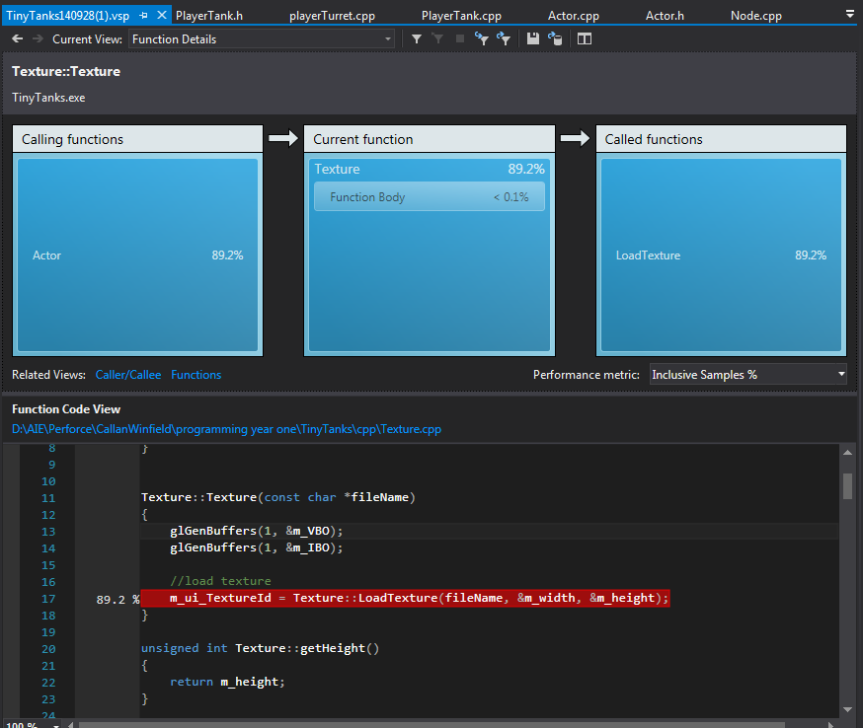

After the optimising of the texture class and the way it loads we can see that the main load of the game is now being pushed back to the sprite batch draw. For the moment this is ok, although I would like to take a look at optimising the opengl draw commands even further.

